Course: CS 223 Digital Design

Section: 6

Lab: 2

Name: Halil AVCI

Student ID: 22003476

Date: 08/10/2023

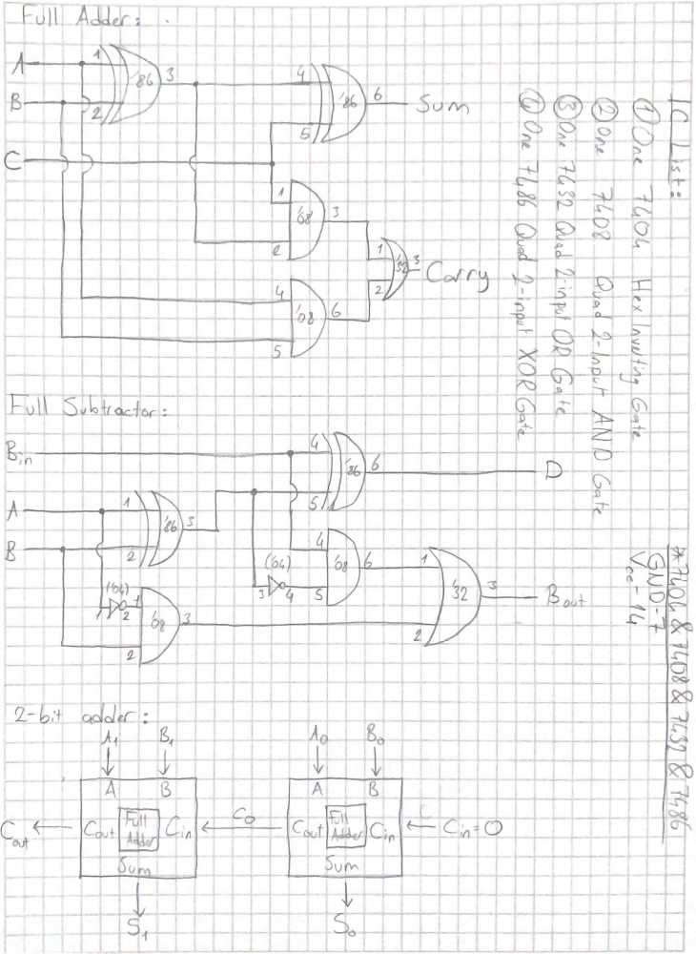
Behavioral SystemVerilog module for the full adder:
`timescale 1ns / 1ps
module fulladder_behavioral (A, B, C_in, S, C_out);
input A, B, C_in;
output S, C_out;
reg S, C_out;
always @(A, B, C_in)
begin
S <= A ^ B ^ C_in;
C_out <= A&B | A&C_in | B&C_in;
end
endmodule

Testbench:
`timescale 1ns / 1ps
module fulladder_behavioral_test;
reg A; reg B; reg C_in;
wire C_out;
fulladder_behavioral uut (.A(A), .B(B), .C_in(C_in), .S(S), .C_out(C_out));
initial begin
#10 A = 0; B = 0; C_in = 0;
#10 A=0; B=0; C_in=1;
#10 A=0; B=1; C_in=0;
#10 A=1; B=0; C_in=0;
#10 A=0; B=1; C_in=1;
#10 A=1; B=1; C_in=0;
#10 A=1; B=0; C_in=1;
#10 A=1; B=1; C_in=1;
end
initial $monitor($time,,"A=%b, B=%b, C_in=%b, C_out=%b, S=%b", A, B, C_in, C_out, S);
endmodule

Structural SystemVerilog module for the full adder:
`timescale 1ns / 1ps
module fulladder_structural (A, B, C_in, S, C_out);
input A, B, C_in;
output S, C_out;
wire S1, C1, C2;
xor xor1(S1, A, B);
xor xor2(S, S1, C_in);
and and1(C1, A, B);
and and2(C2, S1, C_in);
or or1(C_out, C1, C2);
endmodule

Testbench:
`timescale 1ns / 1ps
module fulladder_structural_test;
reg A; reg B; reg C_in;
wire C_out;
fulladder_structural uut (.A(A), .B(B), .C_in(C_in), .S(S), .C_out(C_out));
initial begin
#10 A = 0; B = 0; C_in = 0;
#10 A=0; B=0; C_in=1;
#10 A=0; B=1; C_in=0;
#10 A=1; B=0; C_in=0;
#10 A=0; B=1; C_in=1;
#10 A=1; B=1; C_in=0;
#10 A=1; B=0; C_in=1;
#10 A=1; B=1; C_in=1;
end
initial $monitor($time,,"A=%b, B=%b, C_in=%b, C_out=%b, S=%b", A, B, C_in, C_out, S);
endmodule

Structural SystemVerilog module for the full subtractor:
`timescale 1ns / 1ps
module fullsubtractor (A, B, B_in, D, B_out);
input A, B, B_in;
output D, B_out;
wire D1, B1, B2, B3, B4;
xor xor1(D1, A, B);
xor xor2(D, D1, B_in);
not not1(B4, A);
not not2(B3, D1);
and and1(B2, B4, B);
and and2(B1, B3, B_in);
or or1(B_out, B1, B2);
endmodule

Testbench:
`timescale 1ns / 1ps
module fullsubtractor_test;
reg A; reg B; reg B_in;
wire B_out;
fullsubtractor uut (.A(A), .B(B), .B_in(B_in), .D(D), .B_out(B_out));
initial begin
#10 A = 0; B = 0; B_in = 0;
#10 A=0; B=0; B_in=1;
#10 A=0; B=1; B_in=0;
#10 A=1; B=0; B_in=0;
#10 A=0; B=1; B_in=1;
#10 A=1; B=1; B_in=0;
#10 A=1; B=0; B_in=1;
#10 A=1; B=1; B_in=1;
end
initial $monitor($time,,"A=%b, B=%b, B_in=%b, B_out=%b, D=%b", A, B, B_in, B_out, D);
endmodule

Structural SystemVerilog module for the 2-bit adder:
`timescale 1ns / 1ps
module two_bit_adder (A0, A1, B0, B1, C_in, S0, S1, C_out);
input A0, A1, B0, B1, C_in;
output S0, S1, C_out;
wire C0;

fulladder_structural FA_0(A0, B0, C_in, S0, C0);
fulladder_structural FA_1(A1, B1, C0, S1, C_out);
endmodule

Testbench:
`timescale 1ns / 1ps
module two_bit_adder_test;
reg A0; reg A1; reg B0; reg B1; reg C_in;
wire C_out, S0, S1;
two_bit_adder uut (.A0(A0), .A1(A1), .B0(B0), .B1(B1), .C_in(C_in), .S0(S0), .S1(S1), .C_out(C_out));
initial begin
#10 A0 = 0; A1 = 0; B0 = 0; B1 = 0; C_in = 0;
#10 A0 = 0; A1 = 0; B0 = 0; B1 = 1;
#10 A0 = 0; A1 = 0; B0 = 1; B1 = 0;
#10 A0 = 0; A1 = 0; B0 = 1; B1 = 1;
#10 A0 = 0; A1 = 1; B0 = 0; B1 = 0;
#10 A0 = 0; A1 = 1; B0 = 0; B1 = 1;
#10 A0 = 0; A1 = 1; B0 = 1; B1 = 0;
#10 A0 = 0; A1 = 1; B0 = 1; B1 = 1;
#10 A0 = 1; A1 = 0; B0 = 0; B1 = 0;
#10 A0 = 1; A1 = 0; B0 = 0; B1 = 1;
#10 A0 = 1; A1 = 0; B0 = 1; B1 = 0;
#10 A0 = 1; A1 = 0; B0 = 1; B1 = 1;
#10 A0 = 1; A1 = 1; B0 = 0; B1 = 0;
#10 A0 = 1; A1 = 1; B0 = 0; B1 = 1;
#10 A0 = 1; A1 = 1; B0 = 1; B1 = 0;
#10 A0 = 1; A1 = 1; B0 = 1; B1 = 1;
end
initial $monitor($time,,"A0=%b, A1=%b, B0=%b, B1=%b, C_in=%b, C_out=%b, S0=%b, S1=%b", A0, A1, B0, B1, C_in, C_out, S0, S1);
endmodule

